Linux Exercise
Rx-050637 Payal Maru
6th July’21

1. Create a directory

$ mkdir col

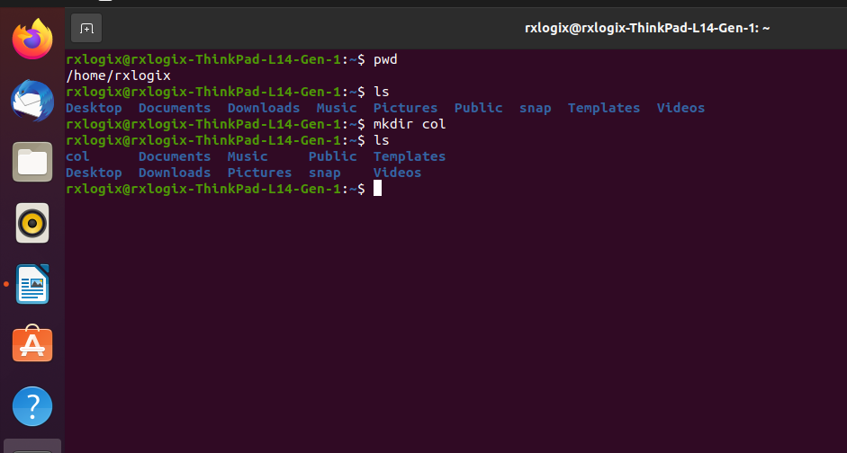

2. Switch to this directory

$ cd col
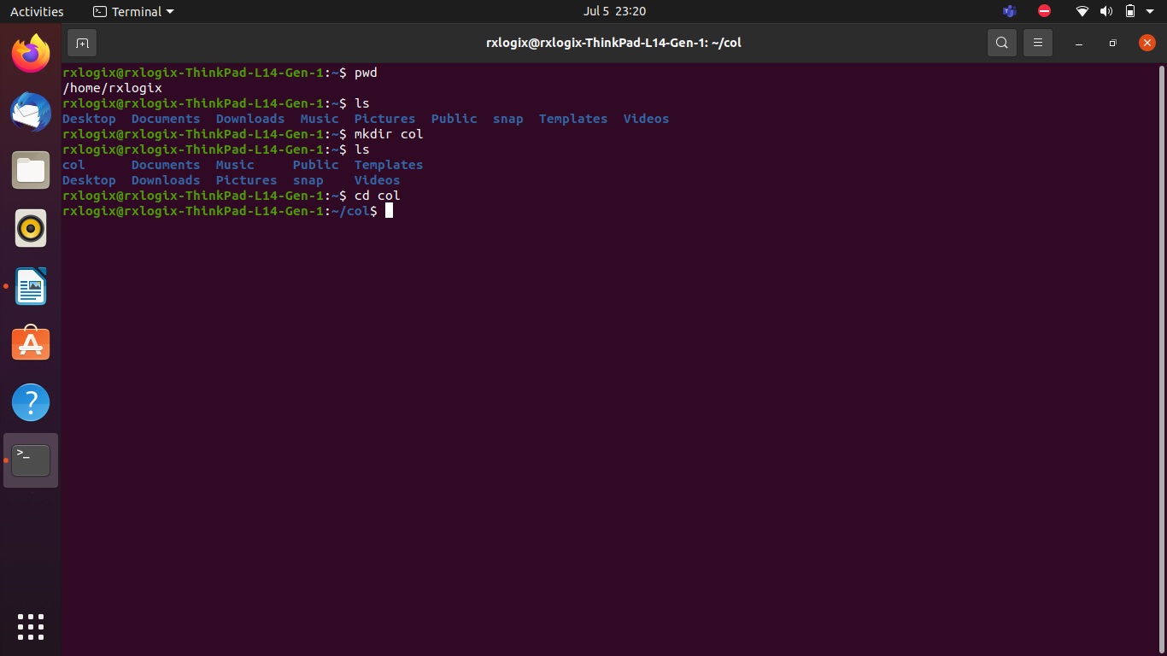

3. Create a normal text file

$ touch pm.txt

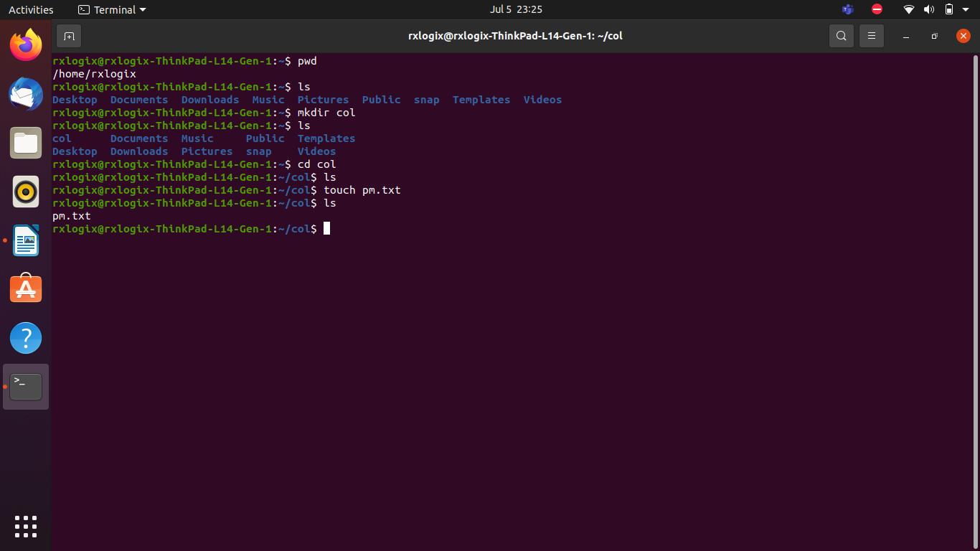

4. Create a hidden text file

$ touch ans.txt
$ mv ans.txt .ans.txt

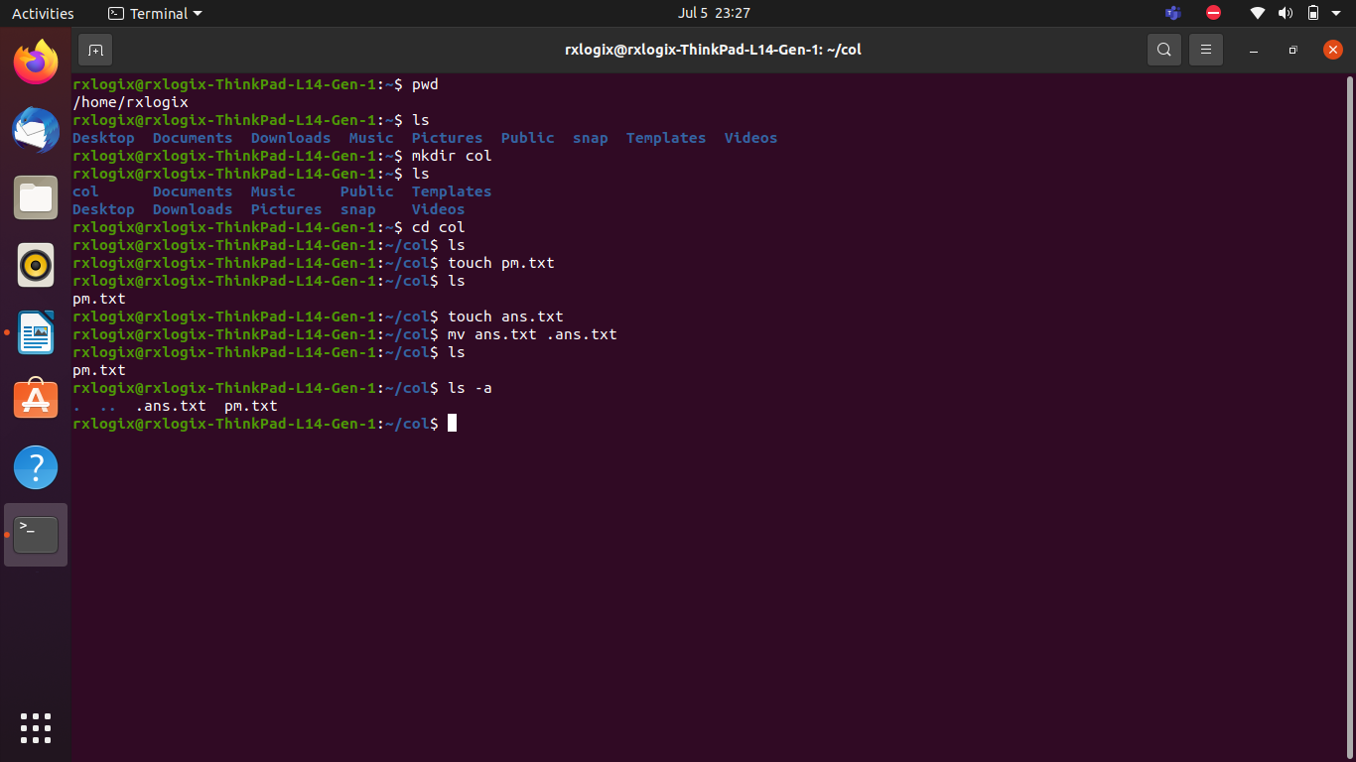

5. Modify the access of the hidden text file so that it can be edited only by root user.

$ chmod 644 .ans.txt
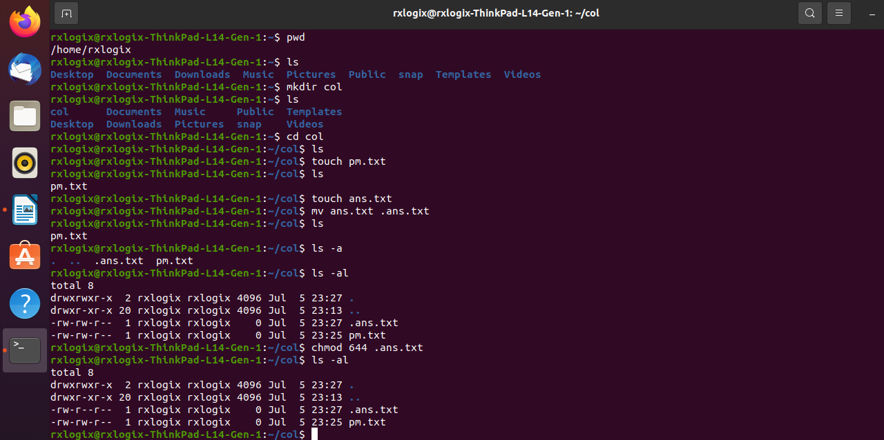

6. Move the hidden file to a your desktop.

$ mv <filename> /<targeted directory>
$ mv .ans.txt /home /rxlogix /Desktop /
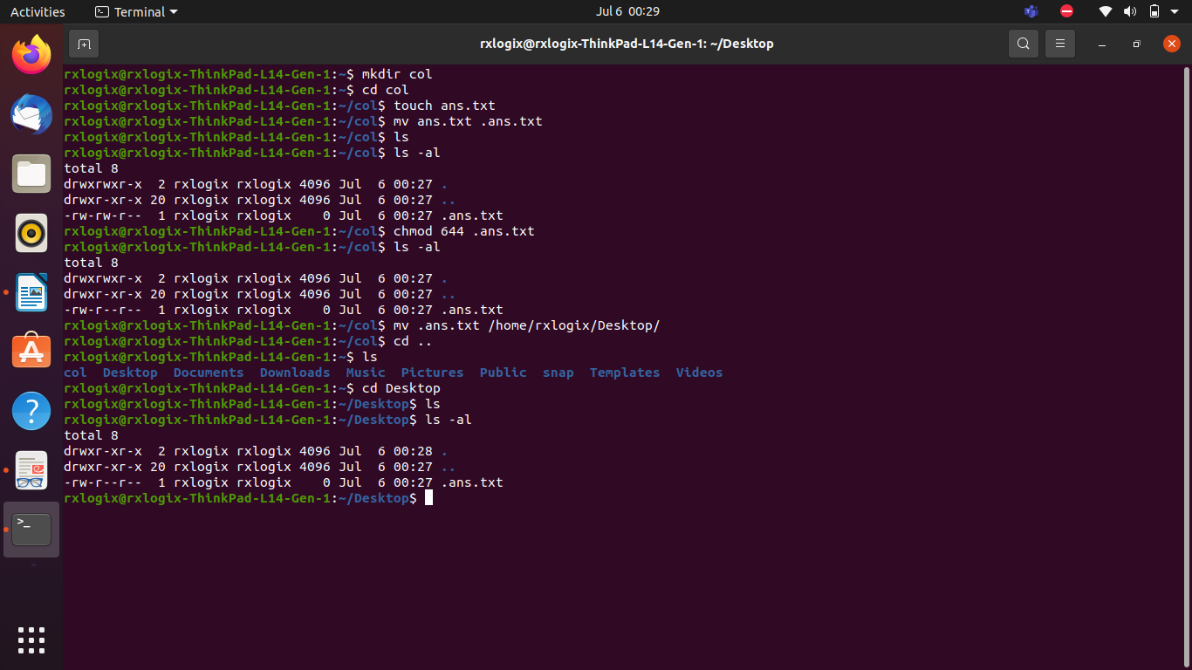

7. Create a directory, add 3 files into it and then remove the whole directory.

$ mkdir test
$ touch file1 file2 file3
$ rm -r test

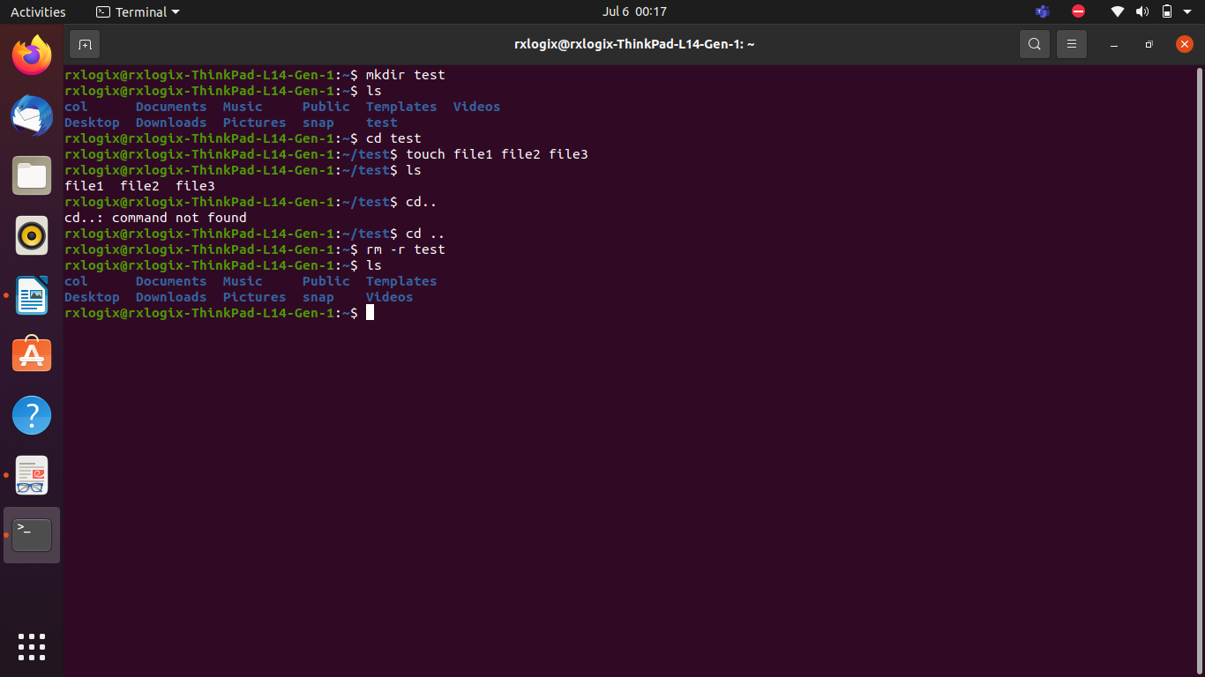

8. Create a new user group.

$ sudo groupadd group1
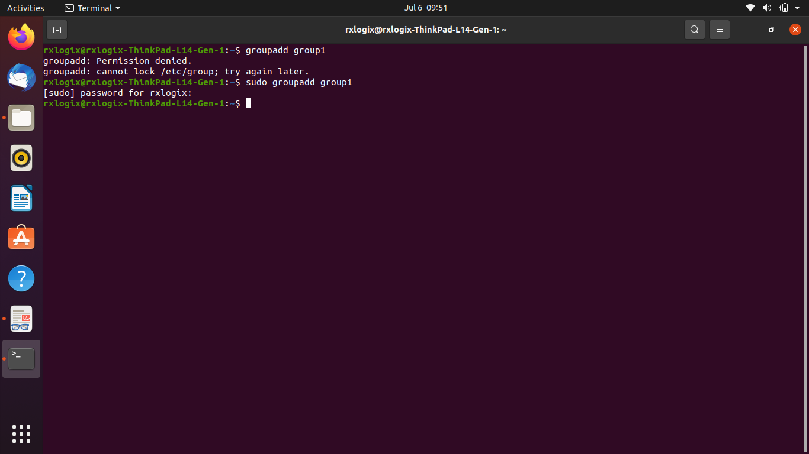

9. Create a new user and assign a new user home and the previously created usergroup to the user.

$ sudo useradd user1
$ sudo usermod -a -G group1 user1

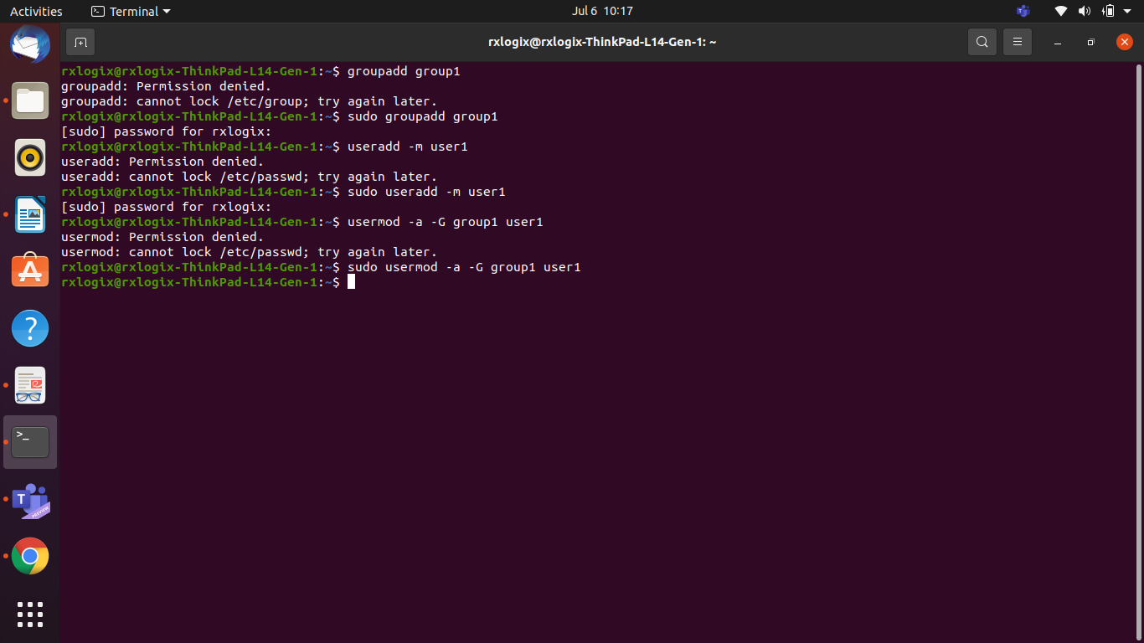
can check by $ cat /etc /group
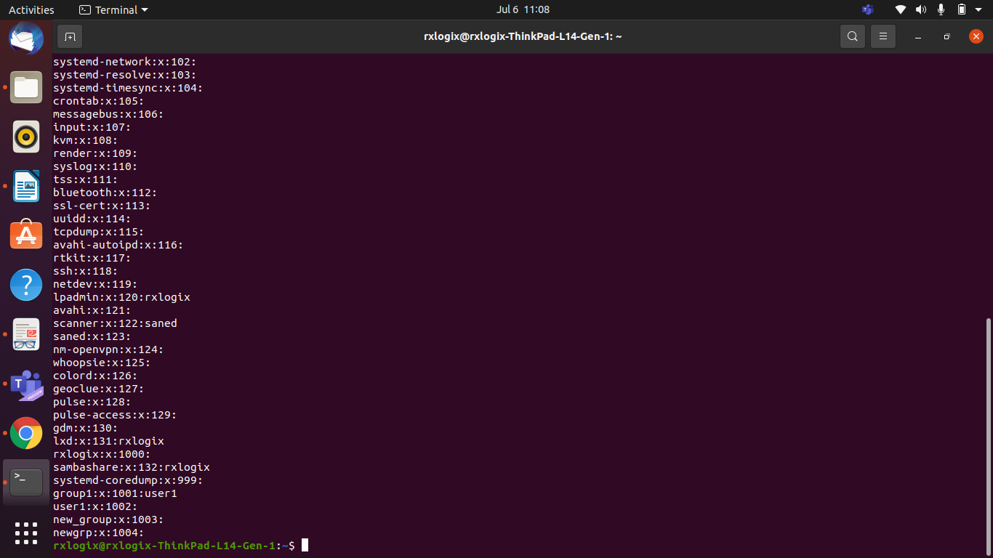

10. Create a symbolic link in a different location for the file created in step 3.

$ ln -s /home /rxlogix / col /pm.txt / home / rxlogix / Dektop / pm_link.txt
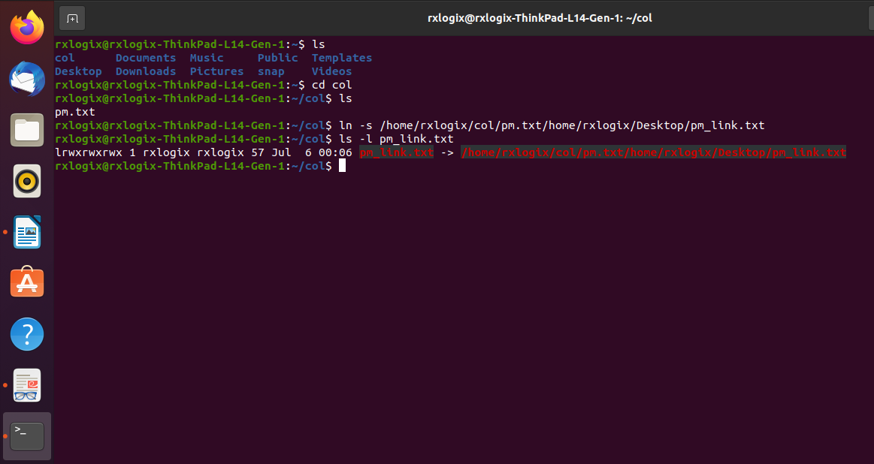

11. Open google chrome or any other web browser, see its memory usage using top command and end the process using the ps and grep commands.

$ top | grep ‘chrome’

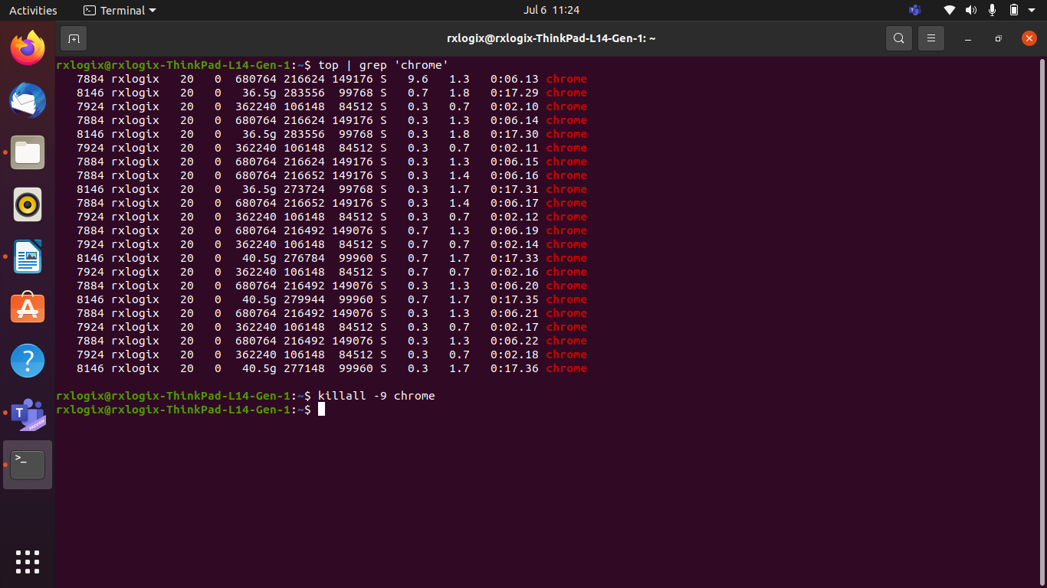

or
$ top
$ ps aux | grep chrome
$ killall -9 chrome

